Fort Jones PERMIT NUMBER |  |  |  |  |  |  |  |  |  |  |  | PERMIT EXPIRES: |  |  |  | 12/31/23 |  |  | PERMITTEE:
 | 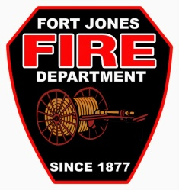 |  |  | RESIDENTIAL BURN PERMIT – BURN PILE  FORT JONES FIRE DEPARTMENT 530-468-2261  FORT JONES CITY HALL 530-468-2281 |  |  |  |  |  |  |  |  |  |  |  |  |  |  |  |  |  |  |  |  |  |  |  | (LAST NAME) |  |  |  |  |  |  |  |  | (FIRST NAME) |  |  |  |  | (M.I.)
THIS PERMIT IS SUBJECT TO THE TERMS  AND CONDITIONS OF USE AS INDICATED |  |  |  |  |  |  |  |  |  |  |  |  |  |  |  |  | (STREET ADDRESS, CITY)
 |  |  |  |  |  |  |  |  |  |  |  |  |  |  |  |  |  |  |  |  |  |  |  |  |  |  |  |  | 96032
 |  | CONDITIONS OF USE |  |  |  |  |  |  |  |  |  |  |  |  |  |  |  |  |  |  |  |  |  |  |  |  |  |  |  |  | (ZIP CODE) |  |  | (PHONE NUMBER)
 |  |  | Burn debris in small 4-foot diameter pile
 |  |  |  |  | Burning Hours: |  |  |  |  |  | Varies
 |  |  |  |  |  |  | Before Burning Call |  |  |  |  |  | 530 842 8123 |  |  |  |  |  |  |  |  |  |  | BURNING LOCATION Same as Above
 |  |  |  |  |  |  |  |  |  |  |  |  |  |  |  |  |  |  |  |  |  |  |  |  |  |  |  |  |  | (Street, Road or Other identity)
 | - This permit is valid only on days which are determined "Permissive Burn Days" by the State Air Resources Board or the local Air Pollution Control District, pursuant to Section 39298 of the Health and Safety Code.  Call 530 842 8123  - This Permit is Void during Suspension of Burning by the DIRECTOR OF THE DEPARTMENT OF FORESTRY AND FIRE PROTECTION.  - This permit does not relieve the User of any legal responsibility for the Safe use of Fire or allow  burning be done in Violation of any State Law, County ordinance or local regulations restricting  or regulating the Use of Fire. |  |  |  |  |  |  |  |  |  |  |  |  |  |  |  |  |  |  | Sec. |  |  |  |  |  |  |  |  |  |  |  | Twp. |  |  |  |  |  |  | R
 |  |  |  |  |  |  |  |  |  |  |  |  |  |  |  |  |  |  |  | I own or legally control the above-described land. I agree to comply with all fire laws, ordinances, regulations, and with all applicable Air Pollution Control District Rules and Regulations. I further agree to comply with specific terms of this burn permit.
 | Issuing Station: FJFD |  |  |  |  |  |  |  |  | Station: |  |  |  | 13 |  |  |  |  |  |  |  | (NOT VALID WITHOUT PERMITTEE'S SIGNATURE)
 | FOR BURNING AND FIRE SAFETY INFORMATION CALL: |  |  |  |  |  |  |  |  |  |  |  |  |  | (530 ) | 468 2261 |  |  |  |  |  | VIOLATIONS OF ANY BURNING PERMIT TERMS ARE A VIOLATION OF  STATE LAW.
 | AREA: Local |  |  |  |  |  | Field Inspection Made Prior to Issuance Yes No |  |  |  |  |  |  |  |  |  |  |  |  |  |  | FIRE CHIEF, Fort Jones Fire Department
 | ISSUE IN PERSON MAILED |  |  |  |  |  |  |  |  |  |  |  |  |  |  |  |  |  |  |  |  | By: |  |  | Carolin Hoefer
 |  |  |  |  |  |  |  |  |  |  |  |  |  |  |  |  |  |  |  |  | Title: |  |  |  | Customer Service Clerk |  |  |  |  |  |  |  |  |  |  |  |  | Date:
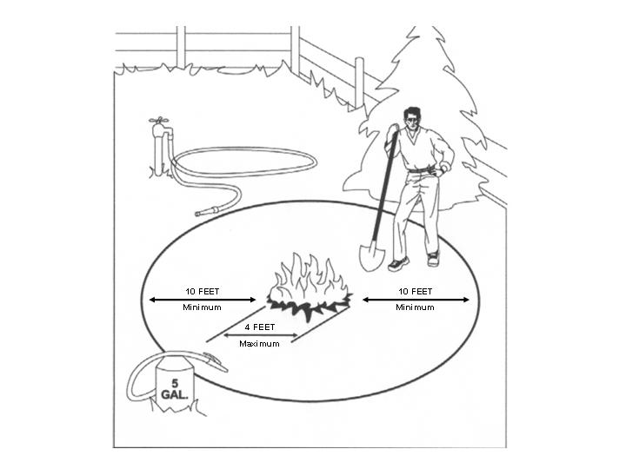 | IMPORTANT
 | THE FOLLOWING ARE BURNING PERMIT TERMS FOR BURNING DEBRIS IN SMALL 4' X 4' PILE:
 | INITAL | 1.  2.  3.  4.  5.  6.  7. | MAXIMUM PILE SIZE 4 FOOT DIAMETER.  AREA WITHIN 10 FEET OF THE OUTER EDGE OF PILE IS MAINTAINED FREE AND CLEAR OF ALL FLAMMABLE MATERIAL AND VEGETATION.  RESPONSIBLE PERSON IN ATTENDANCE WITH SHOVEL UNTIL FIRE IS DEAD OUT.  WATER SUPPLY AT BURNING SITE.  NO BURNING SHALL BE UNDERTAKEN UNLESS WEATHER CONDITIONS (PARTICILARLY WIND) ARE SUCH THAT BURNING CAN BE CONSIDERED SAFE.  NO BURNING OF TRASH/GARBAGE  ADDITIONAL TERMS AND CONDITIONS:  VIOLATIONS OF ANY BURNING PERMIT TERMS ARE A VIOLATION OF STATE LAW  (PUBLIC RESOURCES CODE 4421, 4422, 4423 AND 4425)  Health & Safety Code 13009 states that persons who lose control of a permitted burn may be held liable for suppression costs.

RESIDENTIAL BURN PERMIT

RESIDENTIAL BURN PERMIT
INSTRUCTIONS FOR COMPLETING
FORM LE-62A (Rev. 4/05)

Residential Burn Permit Form LE-62A is specifically designed for burning debris in a 4 foot X 4 foot pile. Units shall make copies as desired for their own administrative use. This Permit will be issued in accordance with the written Unit Burning Permit Plan.

Instructions for Completing Form LE-62A
CONDITION OF USE
1. | "X" the appropriate box for the type of burning.
2. | Where it is required of Permittee to notify the issuing agency prior to burning so indicate by "X" in the "Before Burning Call" box, and write (or pre-stamp) the appropriate telephone number as per Unit Burning Permit Plan. If prior notification is not required, leave the "Before Burning Call" box blank and do not provide a telephone number.
3. | "X" the "Burning Hours" box when burning hours are specified as per Unit Burning Permit Plan and enter authorized burning hours for the burning location.
4. | In areas where the Air Pollution Control District requires small pile burning to be conducted on "Permissive Burn Days", so indicated by "X" in the "This Permit Valid Only on Permissive Burn Days" box, and after "call" write (or pre-stamp) the appropriate telephone numbers for Permittee to use to attain this information as per Unit Burning Plan. If APCD does not have restrictions, leave the box blank and do not provide a telephone number.
5. | The conditions of use may be confusing to the Permittee; therefore, the issuing officer must be sure the Permittee clearly understands by explaining to whom what, when, where, and why calls are to be made prior to burning that burning be done only during burning hours, etc.
PERMIT EXPIRES
Enter (or pre-stamp) the expiration date of the permit as per Unit Burning Permit Plan. Be sure Permittee understands when the permit expires.
PERMITTEE
Print complete name and address, zip code and telephone number of Permittee.
BURNING LOCATION
1. | When the Permittee's address describes the location of burning, enter "address only" for burning location.
2. | Should the Permittee's address not describe the location of burning (i.e. P.O. Box) or the burning location is other than the Permittee's address, enter the appropriate location where burning is to be located. Form LE-62 is for residential burning, therefore, it will be rare that the burning location is different than the address.
3. | Section, Township, Range, need not be completed unless it will assist in describing the burning location.
PERMITTEE'S SIGNATURE
1. | It is not necessary for the permittee to sign the permit prior to issuance. This will allow the permit to be mailed to the Permittee. Permit to be mailed only in accordance with Unit Burning Permit Plan.
2. | Permittee will sign permit prior to issuance where Permittee personally appears for a permit.
DIRECTOR OF CALIFORNIA DEPARTMENT OF FORESTY AND FIRE PROTECTION, BY AGENT, TITLE AND DATE
Issuing officer's signature, title and date of issuance is appropriately entered by personnel authorized to issue the permit as per Unit Burning Permit Plan.
BURNING AND FIRE SAFETY INFORMATION CALL
Enter (or pre-edit) the appropriate telephone number as per Unit Burning Permit Plan.
ISSUING BATTALION
Enter (or pre-edit) the appropriate Battalion identification.
STATION, RESPONSIBILITY AREA, FIELD INSPECTION MADE PRIOR TO ISSUANCE, ISSUED IN PERSON, MAILED
This information is for administrative use and should be completed as per Unit Burning Permit Plan instructions.
DIRECTOR OF CALIFORNIA DEPARTMENT OF FORESTRY AND FIRE PROTECTION
Permit must be signed and dated by issuing officer (Agent).

