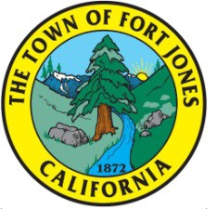
Note Date & Time Change
AGENDA
Special Meeting
MONDAY, June 7, 2021 – 6:00 P.M.
City Hall
11960 East Street Fort Jones, Ca 96032

CALL TO ORDER:
City Council Roll Call: Mayor: DeCausmaker ___Members: Garcia ____ Beckwith _ Sherfy____ Banks____

PLEDGE OF ALLEGIANCE:

Public Comments On Closed Session: (This is the time for community members to bring up items they wish to discuss regarding the closed session item only)

Adjourn to Closed Session:

Closed Session:
- The Council will meet pursuant to Government Code §54957, Public Employee Performance Evaluation Title: City Administrator
- The Council will meet pursuant to Government Code §54957, Public Employee Performance Evaluation Position – Fire Chief

Return to Open Session:

Report on Closed Session: Any Action taken will be REPORTED in open session

ADJOURNMENT: The next Fort Jones City Council Meeting is scheduled to be held on June 14, 2021 at 7:00 p.m. at the City Hall.

